Physics Simulations using OpenGL



**SUBMITTED BY:**

**Muhammad Bilal**

**Class No: 161382**

**SUPERVISED BY:**

**Dr. Jamil Ahmad**

**DEPARTMENT OF COMPUTER SCIENCE**

**ISLAMIA COLLEGE PESHAWAR**

**(SESSION: 2016-2020)**

## 

## **Approval Sheet** We here by recommend that the project entitled “Physics Simulations Gaming (PSG)” submitted by “Muhammad Bilal” is accepted as fulfilling the requirement for the degree of BS Software Engineering.

## 

## **Supervisor:** _____________________________ Mr. Jamil Ahmad Lecturer Department of Computer Science Islamia College, Peshawar

## **External Examiner:** _____________________________

## **Chairman:** _____________________________ Dr. Zahoor Jan HOD Department of Computer Science Islamia College, Peshawar

## **Dated:** 05.03.2021

# DEDICATION

## To three of my favorite and beloved personalities, My Prophet Muhammad (Peace be Upon Him), the Prophet of mankind, the peace of heart and mind, the most generous and kind, my father and my mother whom I love most.

## ACKNOWLEDGEMENT

## First and chief, I would like to thank ALLAH, who gave me the courage and support to continue my graduate studies and project. The determination granted by ALLAH helped me to tolerate the hard times during my graduate studies and this project.

## I offer my countless salutations upon the HOLY PROPHET MUHAMMAD (Peace Be upon Him) the entire source of guidance for the humanity as a whole forever.

## I would like to express my most sincere gratitude to my supervisor Dr. Jamil Ahmad for his support, encouragement, and guidance through every step of this Project. Working with him has been a true privilege and a great experience for me. It has been a real honor for me to work under his supervision.

## I want to appreciate all the teachers of the Islamia College Peshawar. They taught me during my course work, by delivering their precious and valuable thoughts, and built my concepts.

## I would like to thank my mother, brothers, sisters whose efforts, financial support, love, guidance and prayers made it possible for me to complete graduate studies and this project.

## MUHAMMAD BILAL

## Contents

## ABSTRACT…………………………………………………………………………………..9

## Chapter1 1.1Introduction…………………………………………………………………………....10

**1.1Problem and statements………………………………………………………………...11**

**1.3Aims………………………………………………………………………………………11**

**1.4Objectives………………………………………………………………………………...12**

**Chapter 2**

**2.1. Materials ……………………………..………………… ………………………………14**

## 2.1.1. Projectile………………………………………………………………………………... 14 2.1.2 .Pendulum: …………………………………………………………………………….... 15 2.1.3. Vacuum free fall: ………………………………………………………………………. 17 2.1.4 .Air resistive free fall: …………………………………………………………………... 18 2.1.5. Spring compression: …………………………………………………………………..18

## 2.1.5 .1 hooks law ……………………………..………………………………………... 18 2.1.6 .Seesaw: ………………………………………………………………………………… 19

**2.2 .1.Methodology ………………………………………………………………………….. 29**

**2.3.1. system configuration: ………………………………………………………………….. 20**

**CHAPTER 3**

**3 .0 LITERATURE REVIEW OF PHYSICS SIMULATION…………………............…. 21**

**CHAPTER 4**

**4.1. Results ………………………………………………………………..……………... 24**

**4.1.1. Projectile result: …………………………………………………………..………….25**

**4.1.2. Free fall vacuum result: ………………………………………………..……………..26**

**4.1.3 . Free fall in air resistance result ………………………………………..……………..27**

**4.1.4. Pendulum (Time period and length relationship) result …………..…………………28**

**4.1.5. Pendulum (kinetic energy and potential energy conservation) result ………………29**

**4.1.6. Work done on spring result ……………………………………………………………30**

**4.1.7. Seesaw (Torque) result …………………………………………………………………31**

**4.2.1. Conclusion and future work…………………………………………………………….32**

**CHAPTER 3**

**5.1. Reference ………………………………………………………………………………… 33**

## LIST OF FIGURES:

**Figure 1: projectile motion…………………………………………………………15**

**Figure 2: kinetic energy and potential energy conservation………………………15**

**Figure 3: time period and length relationship ……………………………………16**

**Figure 4: free-fall graph……………………………………………………………17**

**Figure 4: spring compression………………………………………………………19**

**Figure 5: seesaw example……………………………………………………………20**

**Figure 6: projectile motion window…………………………………………………25**

**Figure 7: vacuum free fall motion window…………………………………………26**

**Figure 8: Air resistance free fall window……………………………………………27**

**Figure 9: pendulum length and time period window………………………………28**

**Figure 10: pendulum kinetic energy and potential energy window………………29**

**Figure 11: work done on spring window……………………………………………30**

**Figure 12: Seesaw window…………………………………………………………31**

## ABSTRACT

Physics is very difficult subject for students, especially for pre medical students. They fails their entrance test due physics poor understanding. Also, it is difficult for teachers to convey complete concept to students, It is sometime impossible or difficult to do practical of some topics, some physics practices are costly and dangerous in real life. This project includes seven user interactive simulations, based on equations from physics, Projectiles, Pendulums (kinetic energy + potential energy), Pendulums (length + time period), Freefall body in vacuum, Freefall body in presence of drag force, Spring (work load and compression), Seesaw balance (torque). Physics Simulation Quiz Gaming (SQG) is computer 3D graphics game .I took topics from physics text books and created different types of real world problems/objects and implemented them in 3D graphic simulations. simulations are categorized according to the topics. User will interact with these interactive simulations. Using **CODEBLOCK** this simulation application was developed through procedural coding and simple function via libraries; openGL, freeglut and soil. C++ language was used. All program which we created in this project, students can easily learn the physical phenomena from these simulations and teacher can also teach student from these simulations

**CHAPTER 1**

## Introduction

## Introduction

Physics is very difficult subject for students, especially for pre medical students. They fails their entrance test due physics poor understanding. Also, it is difficult for teachers to convey complete concept to students, It is sometime impossible or difficult to do practical of some topics, some physics practices are costly and dangerous in real life. So for the convenience of student and teachers, it is important to simulate physical concepts, in this project we will put all physics concepts in simulation quiz game. It comprises of different levels (easy, medium and hard), for the interest of students there will be IQ levels which will increases with higher levels

## Problem statement

Physics simulation Quiz gaming use openGL library for 3D animation system, the concept of Quiz gaming is very useful in daily life to avoid time wastage of students and teachers in understanding difficult concepts. It is difficult for teachers to animate examples on black/white boards, so it is easy way to predict the exact problem solution.

## Aims

The aim of this system is to simulate physics concepts and represent problems in interactive simulation .Make the concepts clear and easily understandable.

* 1. **Objectives**

The objectives of the system are as follows:

To develop a simulation system to solve physics problems in interesting way.

To save precious time, cost and provide convenient way of learning.

To show practices of problem with accurate results.

**Chapter 2**

**Materials and methods**

**2.1. Material**

This paper includes seven user interactive simulations, based on equations from physics.

1. Projectiles
2. Pendulums (kinetic energy + potential energy)
3. Pendulums (length + time period)
4. Freefall body in vacuum
5. Freefall body in presence of drag force.
6. Spring (work load and compression)
7. Seesaw balance (torque)

## 2.1.1. Projectile:

**Projectile** is a form of two-dimensional motion experienced by an object. Projectile follows a curved path (trajectory) under the action of gravity, while air resistance is assumed to be zero.

 (2.1)

Range = $\frac{V_{°}^{2\sin{2∅}}}{g}$ (2.2)

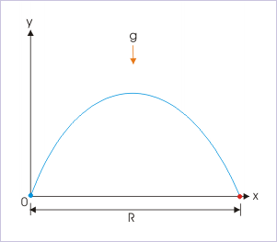

Figure 1. Projectile Motion

Using these formulae this simulation is designed, provided with proper input a user can easily follow the trajectory of a projectile.

## 2.1.2. Pendulum:

**Pendulum**, body suspended from a fixed point so that it can swing back and forth under the influence of gravity. Pendulums are used to regulate the movement of clocks because the interval of time for each complete oscillation, called the period, is constant.In a simple **pendulum,** at extremes the kinetic energy is minimum while potential energy is maximum. At mean positions the kinetic energy is maximum while potential energy is maximum

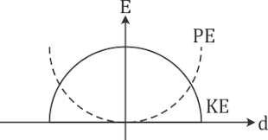

Figure 2: Kinetic energy and potential energy conservation graph

In simple **Pendulum** The oscillatory motion of a simple pendulum: Oscillatory motion is defined as the to and FRO [motion of the pendulum in a periodic fashion](https://byjus.com/physics/periodic-motion/) and the centre point of oscillation known as equilibrium position. The time period of a simple pendulum: It is defined as the time taken by the pendulum to finish one full oscillation and is denoted by “T”. The amplitude of simple pendulum: It is defined as the distance travelled by the pendulum from the equilibrium position to one side. Length of a simple pendulum: It is defined as the distance between the point of suspension to the center of the bob and is denoted by “l”.

$\sqrt[\text{T=2π}]{\frac{\text{L}}{\text{G}}}$ (2.2)

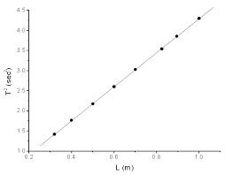

Figure 3: Time period and length relationship

## 2.1.3. Vacuum Free Fall:

Free fall is the motion of a body where its weight is the only force acting on an object.

The acceleration of free-falling objects is called the acceleration due to gravity, since objects are pulled towards the center of the earth.

The acceleration due to gravity is constant on the surface of the Earth and has the value of 9.80 $\frac{m}{s^{2}}$

In **vacuum free fall** two bodies of different masses are compared in the absence of air resistance. free-falling objects are accelerating downwards at a rate of 9.8 m/s2  Objects with higher mass and objects with smaller mass will reach the ground at same time.

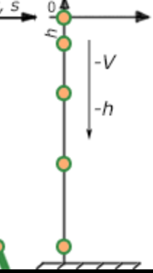

Figure 4: free-fall graph

## 2.1.4. Air Resistance Freefall:

In **air** **resistance freefall**, two objects of different masses are compared in presence of drag force. Objects with higher mass will reach the ground 1st while objects with smaller mass will reach last.

## 2.1.5. Spring compression:

## 2.1.5.1. Hooke’s Law

Hooke’s law of elasticity is an approximation that states that the extension of a spring is directly proportional to the load applied to it.

Mathematically, Hooke’s Law can be written as

$F=-kx$ (2.3)

**2.1.5.2.** **elasticity**:

The property by virtue of which a material deformed under the load can regain its original dimensions when unloaded

In **spring compression** two springs are compared showing the work done on each, and the storage of kinetic energy.

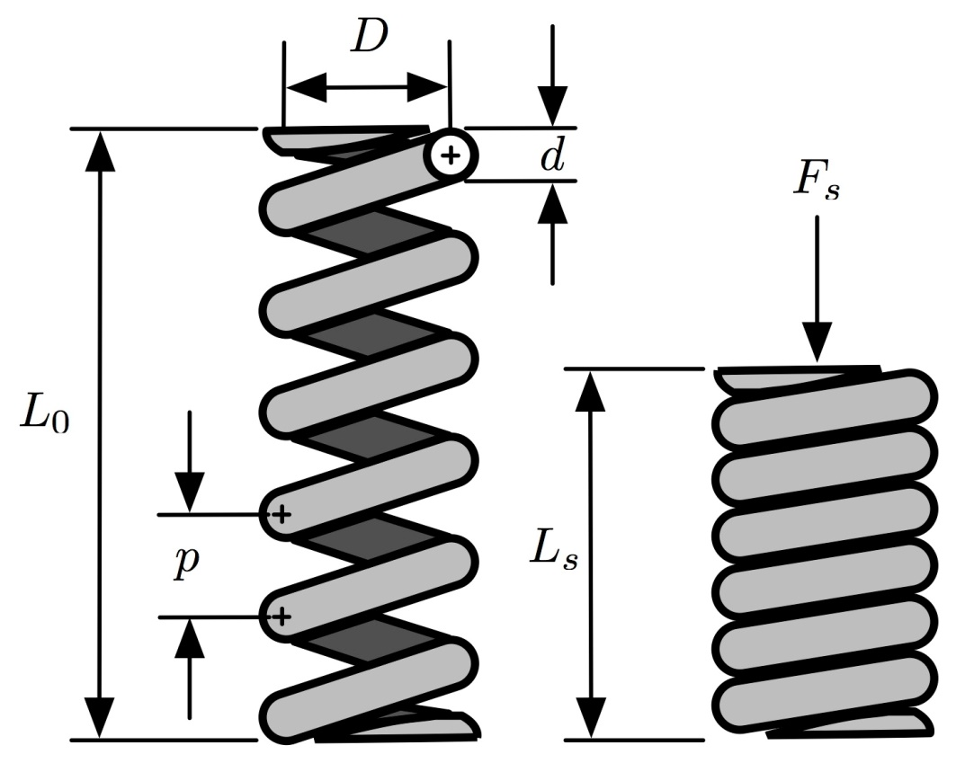

Figure 5: Spring compression

## 2.1.6. Seesaw balance:

## 

In a **seesaw balance**, two boxes with different masses, set apart variably from the pivot point, are weighed against each other to produce torque

seesaw has a pivot point in the middle of the board. When an object is balanced on a pivot point, the force on both side must be equal. its means that on one side of the pivot, the force on one side is counterclockwise and the force on other side is clockwise . To completely level on the pivot point of seesaw board, object must equal the same weight of the other side. However, by placing heavier object on one side and place it closer to the pivot point, balance can be achieved. because the center of the pivot can hold more weight than the other sides. For example, girl sit on the end of a seesaw and a heavier man sit on the other side, man have sit closer to the pivot point than the little girl, as in Diagram  the balance can achieved.



Figure 6: Seesaw Example

## 2.2.1. Methodology:

Physics Simulation Quiz Gaming (SQG) is computer 3d graphics game .I took topics from physics text books and created different types of real world problems/objects and implemented them in 2d graphic simulations and 3d graphic simulations. simulations are categorized according to the topics. User will interact with these game simulations.

Using **CODEBLOCK** this simulation application was developed through procedural coding and simple function via libraries; openGL, freeglut and soil. C++ language was used. With the help of soil library we performed texture mapping make the simulation realistic.

## 2.3.1. System Configuration:

It is compatible with all windows developed recently.

**CHAPTER 3**

**LITERATURE REVIEW OF PHYSICS SIMULATION USING OPENGL**

**3.1. LITERATURE REVIEW OF PHYSICS SIMULATION USING OPENGL**

Interactive computer simulations have been increasingly combined in the teaching of the learning and have contributed important developments in the student the teaching–learning process. ,this paper  (Ceberio, M., Almudí, J. M., & Franco, Á. , 2016) proposed interactive simulation impacts on students improvement in studies. student can understands physic concept clearly .

The use of animation in education may increase conceptual understanding by promoting the formation of dynamic mental models of phenomena. many benefits of simulation in science teaching, science education academics have concentrated on computer simulation to assist student understanding this paper(Akpınar, (2013)) proposed that shows the benefits of simulation of science teaching

Programming interactive physical simulations of rigid and deformable objects requires multiple skills in geometric modeling, computational mechanics, numerical analysis, collision detection, rendering, user interface and haptics feedback, among others. It is also challenging from a software engineering standpoint, with the need for computationally efficient algorithms, multi-threading, or the deployment of applications on modern hardware architectures such as the GPU (Faure, F., Duriez, C., Delingette, H., Allard, J., Gilles, B., Marchesseau, S., … Cotin, S., (2012)) this paper declared need of simulation algorithm .what skill you should need for simulation of physical object.

simulation software covers different stages of interactivity but typically few opportunities to change the models with which it is concerned. This type of software is usually understood of as an aid to the teaching process by raising interest, through graphical displays and animations, as well as involving student participation .this paper (Andaloro, G., Donzelli, V., & Sperandeo‐Mineo, R. M. ()., 1991) explain student take interest in physic simulation software and it also help teacher to convey the concept of physic to their student students.

Our guess about the role of computer simulations in physics teaching is strongly. It seems that educational environments based on simulations support students to overcome their reasoning constraints and their another conceptions about the trajectory motion .This paper (Benacka, 2014) gives the solution and investigation of projectile motion in a vacuum if the launch and impact heights are not equal. Formulas for the maximum horizontal range and the corresponding angle are derived.

Simple pendulum is the most popular textbook example. It has mostly been introduced as an application of Newton’s second law in polar coordinates, or energy conservation. They have presented a comparison between the motion of a simple pendulum based on two frameworks, namely relativistic and Newtonian (Erkal, 2000)

They design and position control of a seesaw like supported beam with angular motion is introduced. controlled with various algorithms by using a digital PC and microcontroller successfully. On the other hand a theoretical model of the system is introduced and simulation results of the model are compared with real implementation. The aim to create a demonstrative simple understandable control system for educational purposes (Uyar, E., Akdogan, T., Keskin, O., & Mutlu, L., 2012)

**CHAPTER 4**

**RESULTS AND CONCLUSIONS:**

**4.1. Results**

**4.1.1. Projectile motion simulation application result**

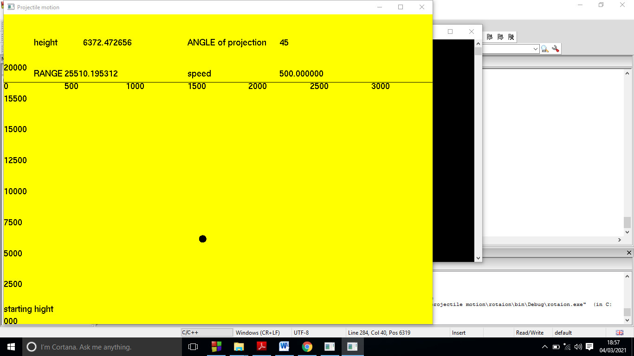**Figure 7: projectile program window**

* The ball is moving 2D projected angle is 45 degree .
* Initial velocity is 500.
* Total Range is 25510.19
* Maximum height is 6372

When We change its angle or speed of projectile with help of popup manu which we created in the program. The ball speed and angle also changed. They gives results correctly according to inputs(initial velocity, and angle).

**4.1.2. Vacuum free fall result**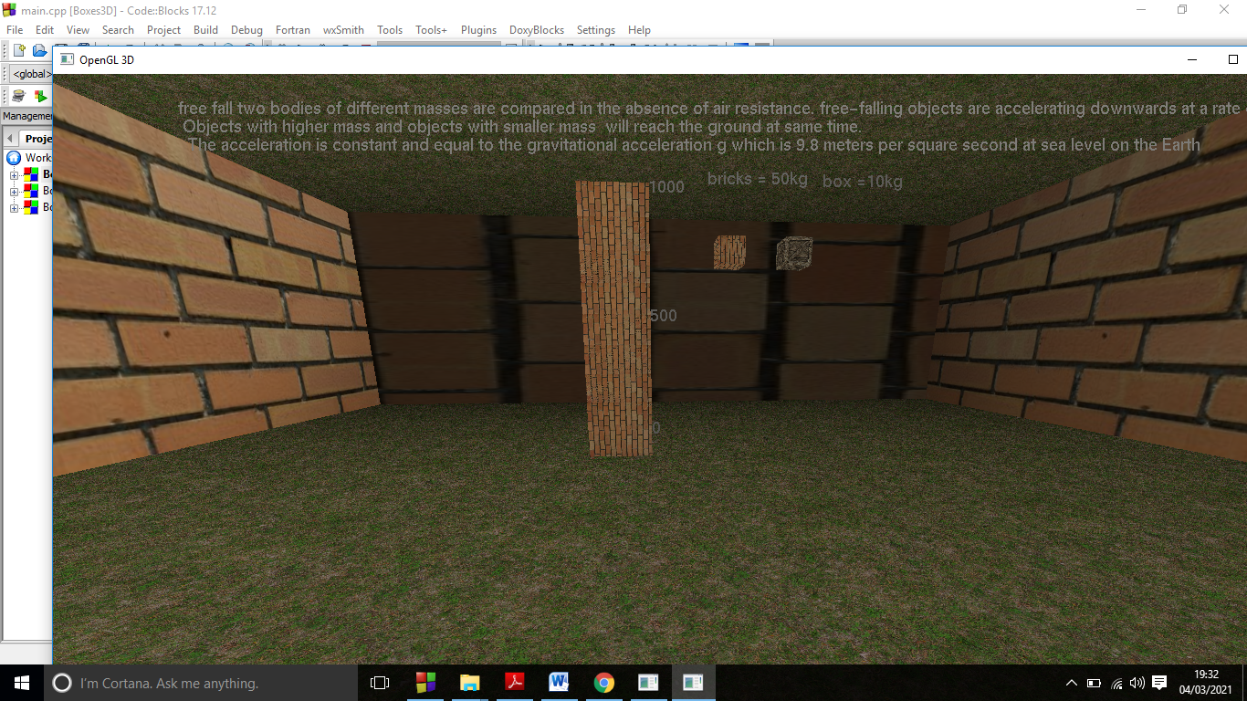

Figure 8: Vacuum free fall window

**4.1.3. Air resistance free fall result**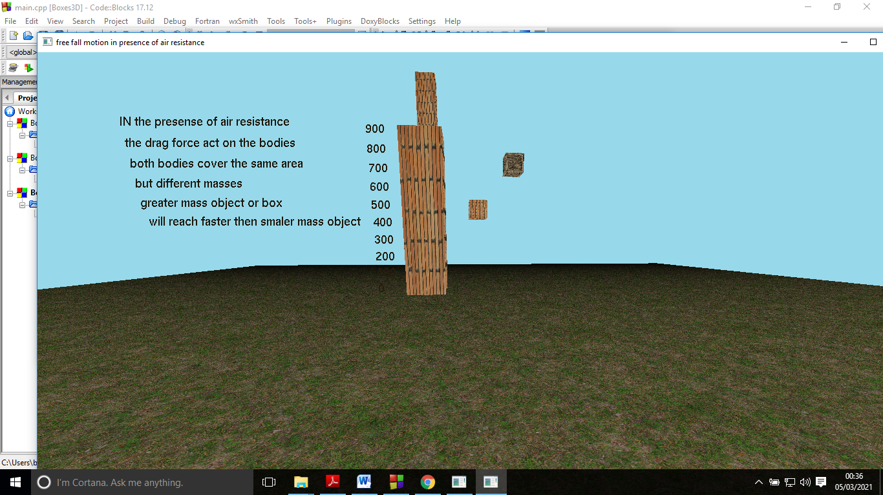

Figure 9: Air resistance free fall window

Free fall motion in the presence of air résistance. Two boxes of different masses is falling from certain height at same time.

The greater mass box reach first to the ground. Then lighter masss box .

In this program wooden box is lighter then bricks box.

When we test in the program the bricks box reach first to the ground.

And show accurate simulations.

**4.1.4. Pendulum in length and time relationship result**

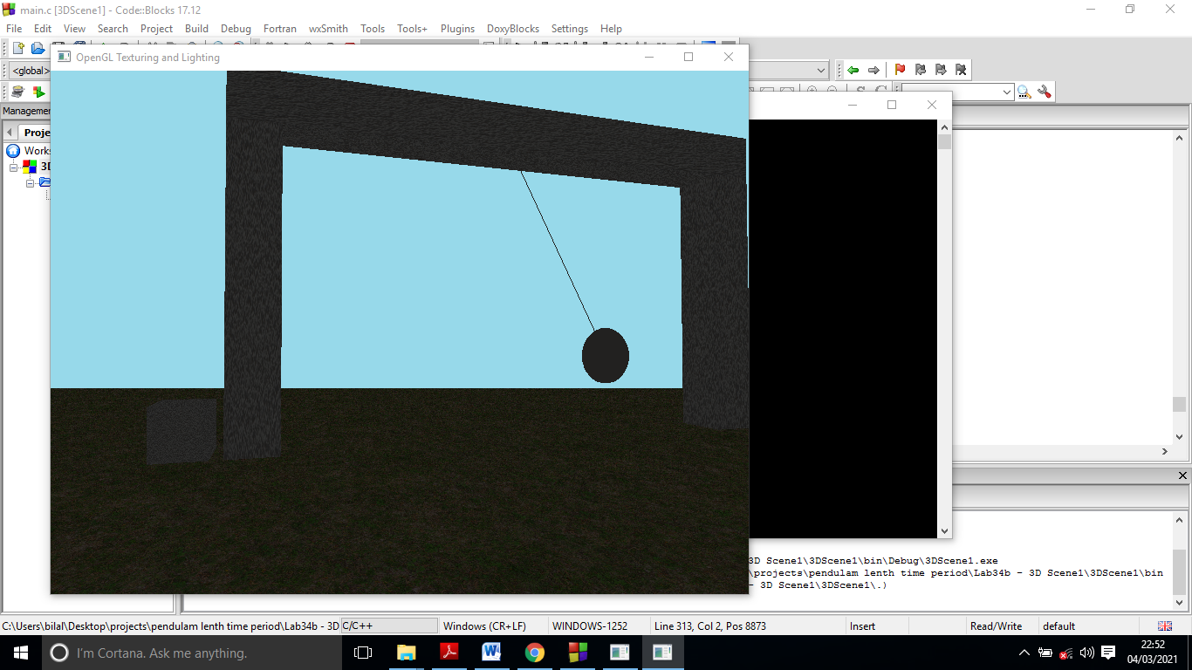

Figure 10: Pendulum in length and time relationship window

* The results of pendulum showing the direct proportionality between length

of pendulum and the time period of pendulum .

* when we changed the length of pendulum the time period pendulum also changed.
* Greater the length of pendulum greater will be the time period of pendulum.
* We observed that greater the length of pendulum have longer time period.
* The pendulum behave the same as pendulum behave real world..

**4.1.5. Kinetic and potential energy conservation result**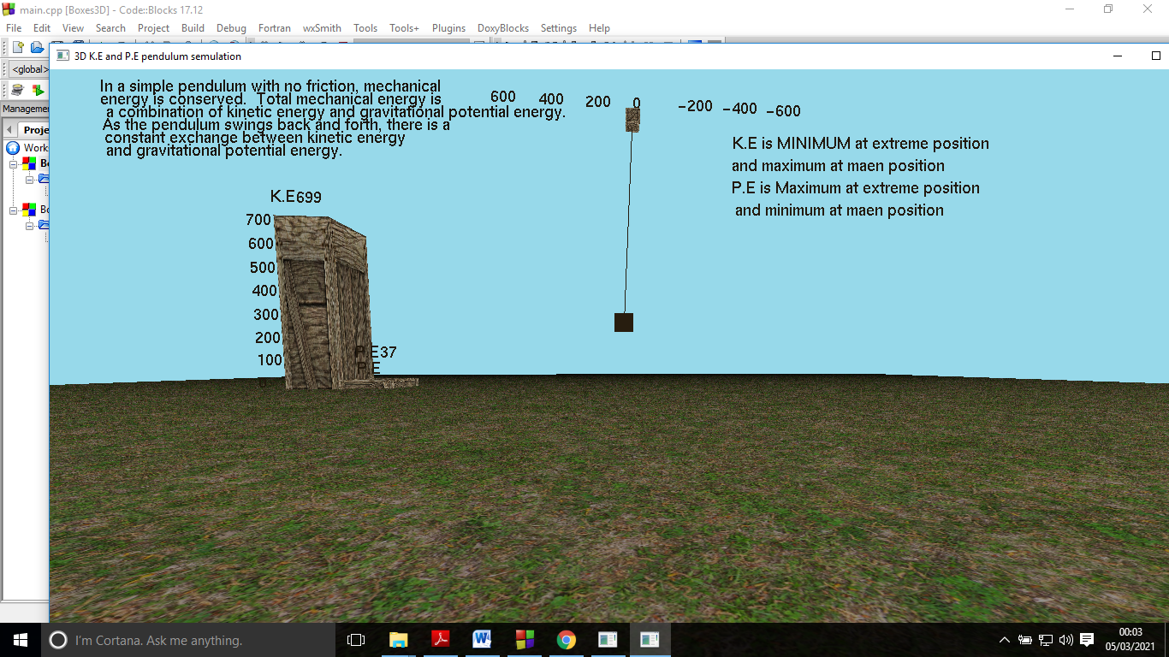

Figure 11: Kinetic and potential energy conservation window

In the figure 11 Kinetic and potential energy conservation window .pendulum, at extremes position the kinetic energy is minimum and potential energy is maximum. At mean positions the kinetic energy is maximum and potential energy is minimum. In this simulation the K.E bar show the K.E and P.E bar show the P.E .The K.E changing to P.E .as we read in physic book.

The total energy of the pendulum can not destroyed .It is conveted from one form of energy to another form of energy.

In pendulum K.E convert in to P.E and P.E convert in to K.E

**4.1.6. work on spring window result**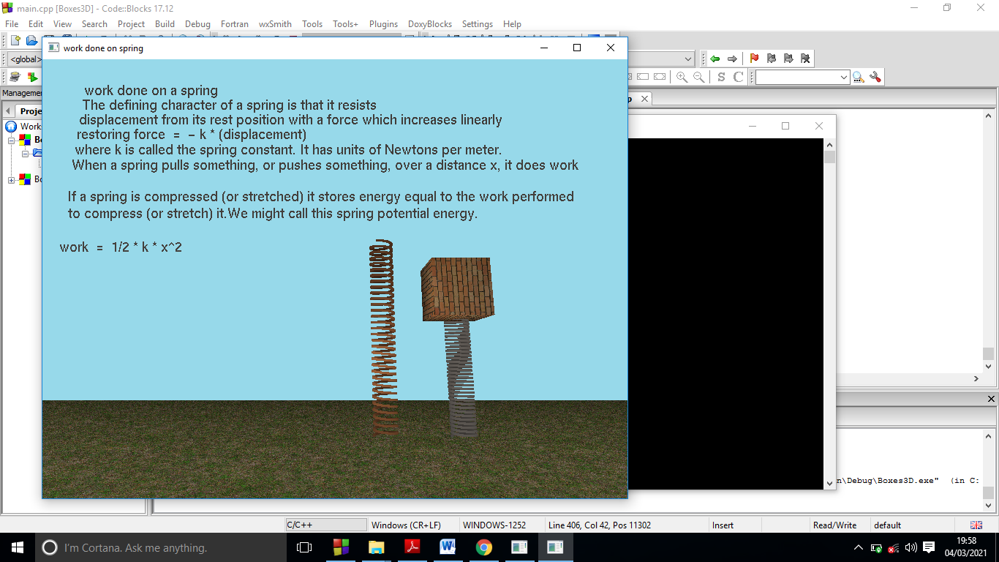

Figure 12: work on spring window

In the simulation window result we load weight on spring and the spring is compressed from mean position.and the spring become compressed according to weight. When we increase weight the spring will compress more .

This simulation give result just like the spring in real world.

The spring change its length when external force or weight applied on spring.

**4.1.7. Seesaw result**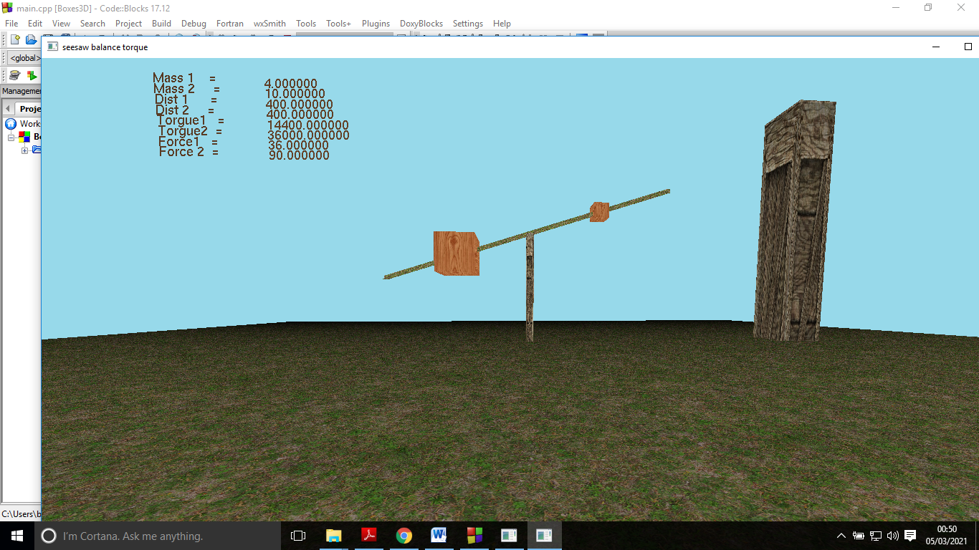

Figure 13: Seesaw window

In Figure 13 .we developed a simulation of seesaw .

* Mass1=4

Box1 weight is Mass1.

* Mass2=10

Box2 weight is Mass2.

* Dist1=400

Distance of box1 from pivot point.

* Dist1=400

Distance of box2 from pivot point

* Torque1=14400
* Torque1=36000
* Force1=36
* Force1=90

The box which produce maximum torque is heavier. the seesaw rotate anti clock wise.

**4.2.1. Conclusion and future work**

We have presented simulation of physics in 3 dimensional and 2 dimensional. Using language c++, opengl and free glut library. In code blocks IDE.we developed seven simulation application of physic Projectiles, Pendulums (kinetic energy + potential energy),Pendulums(length + time period),Freefell body in vacuum, Freefall body in presence of drag force., Spring (work load and compression) and Seesaw balance (torque) .From all program which we create in this project students can easily learn the physical phenomena from these simulations and also teacher can also teach student from these simulations. These programs simulate very clearly physics concepts.

In future you should work more simulate other physics concepts like collision, impulse, inertia, three laws of force, waves etc. I Used simple opengl library in code blocks IDE. By using blinder and Opengl you should get far better results then simple opengl.

## References

1. Hewitt P.G, conceptual physics third edition, Pearson education, ISBN 81-317-15531
2. A Textbook of physics for grade Ⅺ. KPK textbook board peshawar Pakistan, code no: PSP/RPP-17-67-2021(O)
3. 4 Andaloro, G., Donzelli, V., & Sperandeo‐Mineo, R. M. (1991). *Modelling in physics teaching: the role of computer simulation. International Journal of Science Education, 13(3), 243–254.* doi:10.1080/0950069910130303
4. 7 Benacka, J. (2014). *Projectile general motion in a vacuum and a spreadsheet simulation. Physics Education, 50(1), 58–63.* doi:10.1088/0031-9120/50/1/58
5. 8 Erkal, C. (2000). *The simple pendulum: a relativistic revisit. European Journal of Physics, 21(5), 377–384.* doi:10.1088/0143-0807/21/5/302
6. 9 Uyar, E., Akdogan, T., Keskin, O., & Mutlu, L. (2012). *Position control of a seesaw like platform by using a thrust propeller. 2012 12th IEEE International Workshop on Advanced Motion Control (AMC).* doi:10.1109/amc.2012.6197019
7. 1 Ceberio, M., Almudí, J. M., & Franco, Á. (2016). *Design and Application of Interactive Simulations in Problem-Solving in University-Level Physics Education. Journal of Science Education and Technology, 25(4), 590–609.* doi:10.1007/s10956-016-9615-7
8. Akpınar, E. (2013). *The Use of Interactive Computer Animations Based on POE as a Presentation Tool in Primary Science Teaching. Journal of Science Education and Technology, 23(4), 527–537.* doi:10.1007/s10956-013-9482-4
9. Faure, F., Duriez, C., Delingette, H., Allard, J., Gilles, B., Marchesseau, S.,Cotin, S., (2012) SOFA: A Multi-Model Framework for Interactive Physical Simulation, Soft Tissue Biomechanical Modeling for Computer Assisted Surgery.